EVZ11-321
BARCODE SCAN MODULE

SPECIFICATION

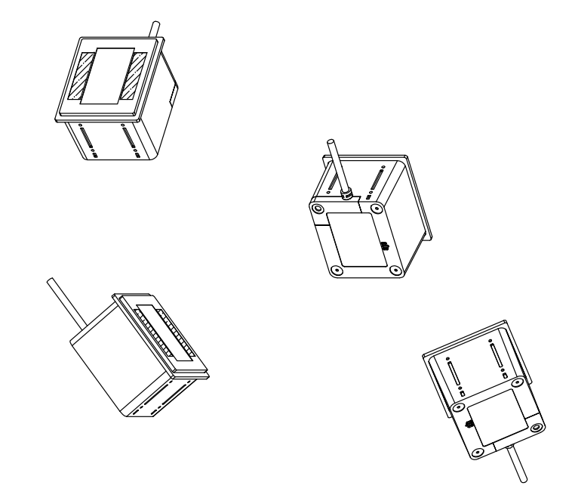

Version：V1.0

VERSION DESCRIPTION：

VERSION | DESCRIPTION | ISSUE DATE
V1.0 | initial version | 2019.05.17

Interface | USB；  RS-232；
Voltage | DC 5V±5%(USB、RS232、RS485)  DC 3.3V±5%（TTL）
Current | 135mA（Max） 74ｍA（Min）
Light source | 8pcs of LED
Photo sensor | CMOS array sensor
Resolution | 640×480 pixel
Reading angle | tilt: ±30°  skew: ±40°  pitch: ±180°
Field of View | H 68°，V 54°
Min resolution | ≥5mil
Reference depth of field | Barcode | material | Density | Dimension | Min | Max
Reference depth of field | QR Code | screen | 44.17mil | 23mm*23mm | 0 | 19
Reference depth of field | QR Code | paper | 44.17mil | 23mm*23mm | 0.5 | 18
Reference depth of field | Code128 | paper | 20mil | 62mm*15mm | 4 | 24
Reference depth of field | Code128 | paper | 15mil | 43mm*15mm | 2 | 13
Support Symbol | 1D : Code 128,Code 39,Code93，EAN-8,EAN-13,UPC-A,UPC-E,ISBN,ISSN
Support Symbol | 2D：QR Code
Operating temperature | -10°C - 60°C
Storage | -10°C - 70°C
Working humidity | 5%~95% (No condensation)
Dimension | 78mm x 67mm x 54mm(L*W*H)
Secondary development | Support secondary development. Through serial port instructions

Product specification six-side map 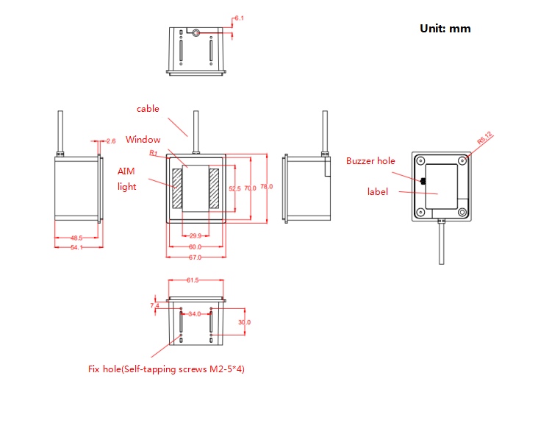

Integration guide

Chapter 1: Installation

ESD
Z11-321has been designed to protect against static electricity and uses anti-static packaging. However, anti-static measures should be taken during unpacking and use, such as the use of grounding wrist straps and grounding of work areas.

Dust-proof and Antifouling
Z11-321 must have sufficient sealing during storage and use to prevent dust, particles or other contaminants from adhering to the lens, circuit board and other components. Dust particles or pollutants can reduce the performance of the engine and even affect the use of the engine.

Environment
The normal use of the module is subject to the following environmental requirements.

Operation Temp | 0°C-５0°C
Storage Temp | -5°C-５5°C
Humidity | 5%~95% (No condensation)

Heat dissipation considerations
The Z11-321 emits heat during operation. Under the condition of continuous operation at full speed for a long time, the heat will accumulate to increase the temperature of the decoder chip. Although the Z11-321 can be adapted to work in high temperature environments, in high temperature environments.
it will increase Image noise to reduces image quality and reduces read performance. When considering the Z11-321 integrated in a high temperature environment, it is recommended to test whether the possible read performance degradation is within an acceptable range, and then determine whether to perform proper heat dissipation design.

- When designing, reserve space for Z11-321 that may form a ring forced convection natural convection

- Avoid using insulation materials such as rubber to wrap Z11-321

Power on, power off, standby and reboot
Power on: Connect the product to the host, and the scan engine automatically turns on and is working.
Power off: Remove the USB data cable/power adapter plugged into the RS-232 cable of the product that connects on the host.
Reboot：If the product crashes or does not respond, please turn it off and on again to restart.

Maintenance
*The reading window must be kept clean, suppliers are exempt from warranty liability for damage caused by improper maintenance
*Avoid hard and rough objects from wearing or scratching the reading window
*Use a brush to remove stains from the recognition window
*Please use a soft fabric to clean the window. Such as glasses cleaning fabric and lens cleaning fabric
*Do not spray any liquid into the window
*Do not use any other detergent beside clean water

Mounting orientation
There are 4 self-tapping screw mounting holes on each side of the Z11-321. As shown in the below photo, the left and right direction of the Z11-321 is correct, and the captured image also corresponds to the left and right direction. The photo below shows the appearance of the Z11-321 when placed and installed correctly.

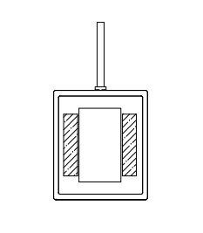
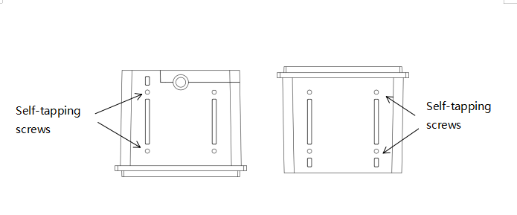

Window placement
The window is a transparent medium mounted on the front of the Z11-321 to isolate the inside and outside of the product and retain the light path for the Z11-321 to read the bar code. The window should be placed so that the illumination and aiming beams are emitted as much as possible and the reflections are prevented from entering the engine. If the illumination beam is reflected into the engine, it will reduce the engine's reading performance.
The installation of the window is recommended to be close to the front of the Z11-321 and parallel to the front plane of the Z11-321. This can achieve good reading performance. It is necessary to avoid the illumination of the Z11-321 from entering the engine through the window. At the same time, the thickness of the window material should be minimized.
If the window needed to be tilted, the angle of inclination should be such that there are no various beams that can be reflected into the lens to ensure readability.

Window material and color
The material and color of the window should be selected in consideration of the wavelength of the light wave (mainly white light band) that the Z11-321 can respond to, so that the light transmittance is as high as possible, while ensuring the lowest possible ambiguity and uniform refractive index. Generally, PMMA or optical glass can be used. The white light transmittance of the window material is greater than 90%, and the ambiguity is less than 1%. Whether or not the coating is applied to the window material depends on the specific material and application.

Window scratch and coating
Scratch on the window will reduce the reading performance of the Z11-321. It is recommended to consider the window anti-scratch and anti-fouling in the design. Consider choosing high wear-resistant materials or wear-resistant coating on the window material.

Window size

Mounting
When integrating the Z11-321, refer to the following physical size specifications. Structural design, note that other components cannot be oppressed Z11-321 component

Z11-321 Front view（unit：mm）
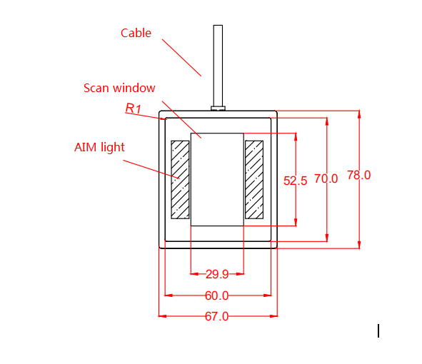

Z11-321 Side view（unit：mm）

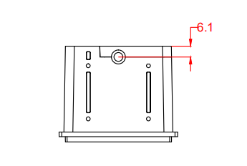

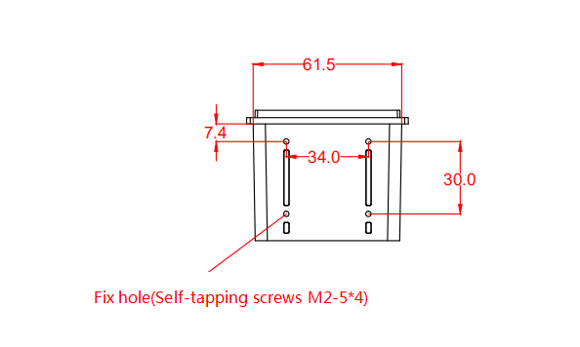

Z11-321Top view（unit：mm）

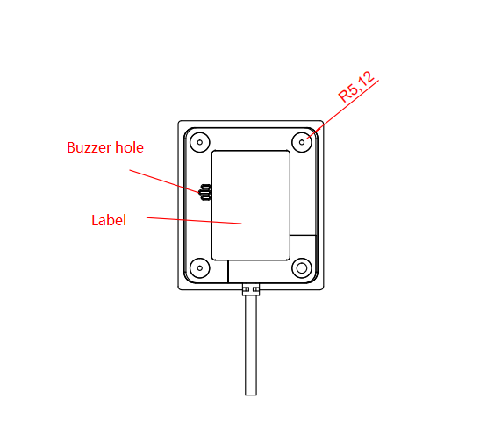

Chapter 2:Electrical characteristics

Power requirement
Power input must be after the Z11-321 is connected. If the Z11-321 is plugged or unplugged while the power is turned on, the electronic components of the Z11-321 will be damaged. Please ensure that the power is turned off when the Z11-321 is plugged or unplugged.
A poor power connection, or a short-interval power on and off operation, or an excessive voltage drop may cause the Z11-321 won’t be in a stable and normal operating state, and the power input must be kept stable. After turning off the power input, it takes more than 2 seconds to turn the power input on again.

Ripple noise
Since the power input of the Z11-321 is directly supplied to the image sensor and the decoder chip, in order to ensure stable operation, a power supply input with low ripple noise is required. It is recommended to control the ripple noise to within 30mV (peak-to-peak), and at least not to exceed 50mV (peak-to-peak).

DC characteristics
Working power | Standby current | Operation current
5V | 74mA | 135mA

Chapter 3: Interface

Hardware interface introduction
The physical interface of Z11-321 can be selected as USB data cable and DB9 serial data cable (both not plug gable)

USB Cable interface definition
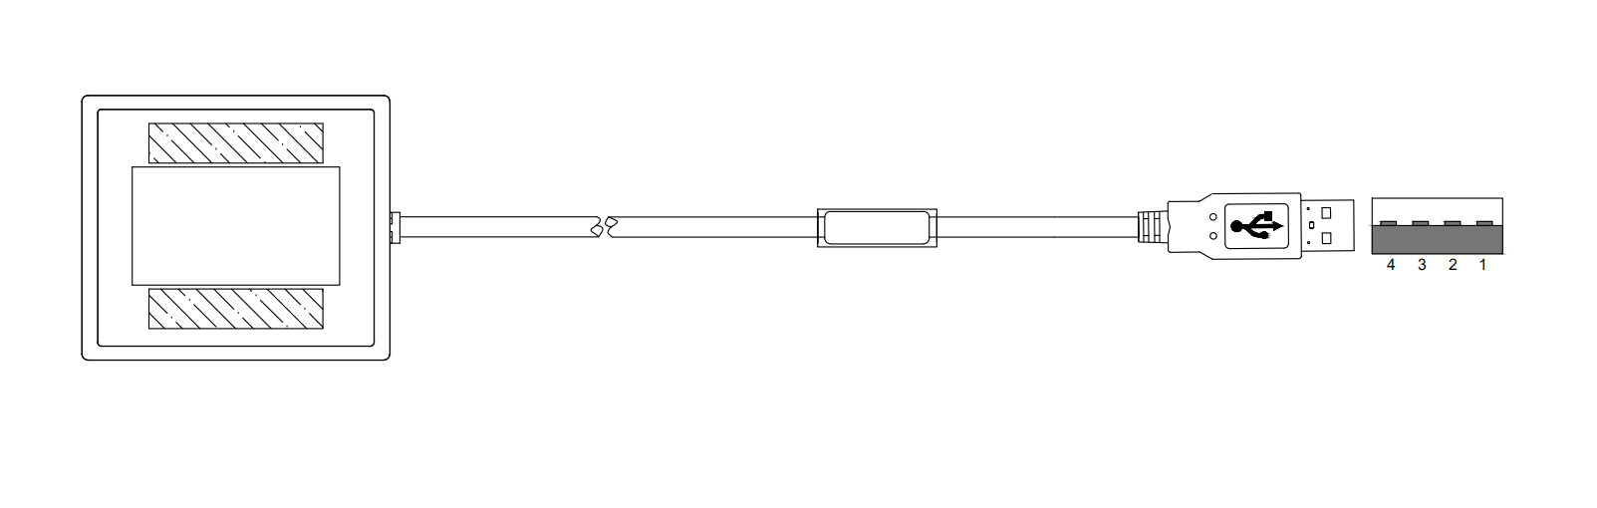
Item | Signal description | 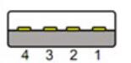
1 | 5Vpower input
2 | USB_D-
3 | USB_D+
4 | Power ground

RS232 Cable interface definition

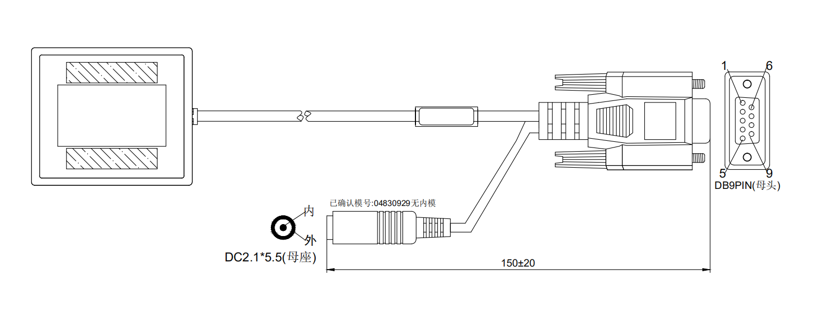
PINOUT | Function | 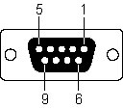
1 | Trigger(optional)
2 | Rx
3 | Tx
5 | GND
9 | DC 5V(optional)

Chapter 4: Field of View

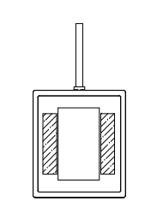
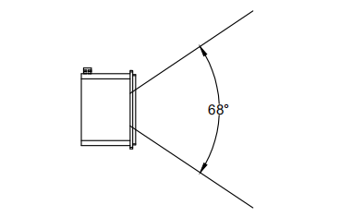

The horizontal viewing angle of the scan engine is 68°
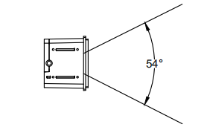

The vertical viewing angle of scan engine is 54°

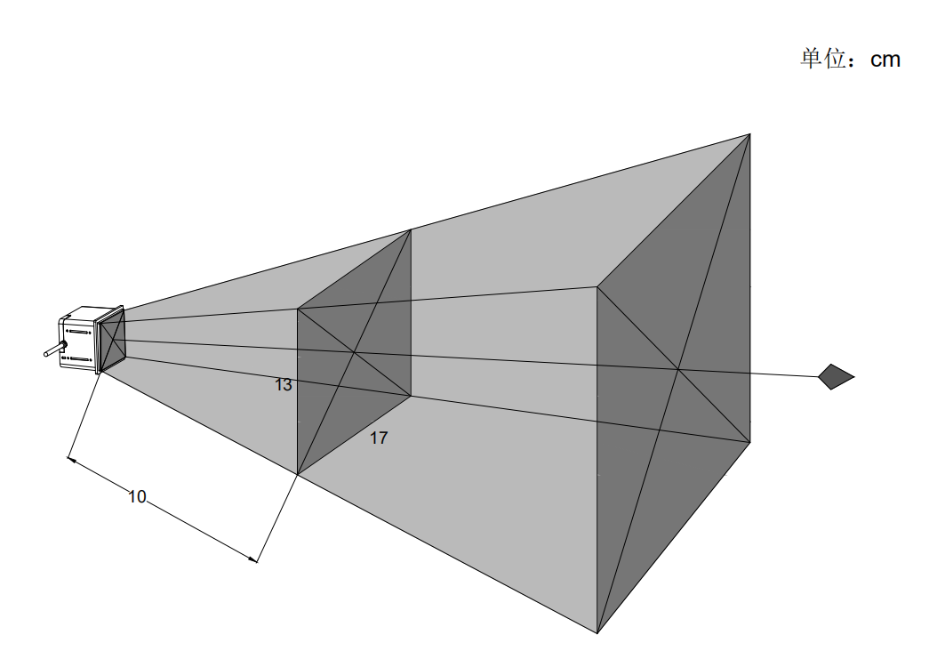

Item | specification
Imaging range (length x width) at a distance of 10 cm from the window | 13cm x17cm

