Magnetic Card Reader F770
- Model: F770
- Interface: RS232
- Power supply: DC5V-24V
- Dimension: 102 x 36 x 37mm
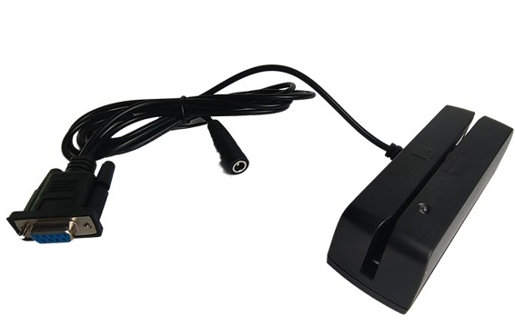
Overview:
F770 magnetic card reader is developed under 32bit Cortex-M3 platform with working frequency 72MHz. It can read and decode the magnetic card , credit card compatible with ISO7811 ,AAMVA standard rapidly and accurately.
F770 works under RS232 interface or USB interface. With the powerful setting utility, users can set the output format flexibly and expediently. F770 can be used in shopping mall, supermarket, GPS, CVS, as well as being set into Kiosk terminals such as ATM, self-service terminals.

Technical Features:
l Power supply：DC 5V/±10% , or DC 5V-24V optional for truck application
l Power Mode： 5V from USB port or 5V power adapter , 5V-24V from external power supply
l Electric Current：stand by status : ≤80mA . Crest value under working：≤100mA
l Interface : USB/RS232
l USB mode: USB Keyboard / USB HID mode set by setting utility,
USB virtual COM port set by DIP switch
l Magnetic Card reading features：
Track | Track 1 | Track 2 | Track 3
Recording density | 210 BPI | 75 BPI | 210 BPI
Capacity | 79 characters  (7 bit code) | 40 characters  (5 bit code) | 107 characters  (5 bit code)
support dual direction swipe.
Support ISO/IEC7811 standard.
Support AAMVA standard.
Card swiping speed：10cm/s~120cm/s.
Swiping lifetime: ≥1,000,000 passes.
Operation responded by LED and buzzer.
l Working Environment：Temperature -10~50℃, Humidity 10%~90%.
l Support USB1.1/USB2.0 standard.
● Dimension（L×W×H）：102mm×36 mm×36.7mm
● Color: Black
● Cable Length: 1.5m

Structure Features:
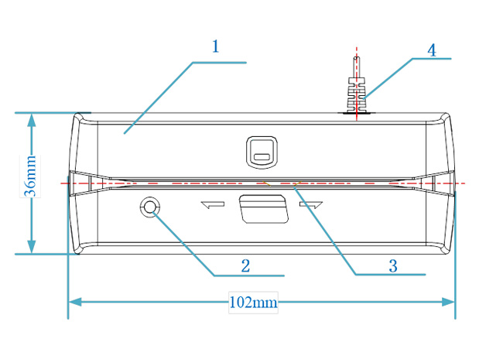
1. Main housing
2. Status LED (blue and red)
3. Swiping slot
4. Communication cable

DIP Switch Definition:
There is a DIP Switch on the main board. The settings definition is following:

SW1 | SW2 | Interface Mode
ON | ON | USB Virtual COM Port
ON | OFF | USB HID Mode
OFF | ON | RS232 Mode (115200,8,N,1)
OFF | OFF | RS232 Mode (9600,8,N,1)

SW4 | Status
ON | F/W updating mode
OFF | Working mode
SW3 has no definition.

Setting Utility Layout:
