Dual Heads Magnetic Card Reader F780
- Model: F780
- Interface: RS232/USB VCP/USB HID
- Power supply: 5V or 5V-24V optional
- Dimension: 116mm×36 mm×40mm

Overview
F780 Dual face magnetic card reader is developed under 32bit Cortex-M3 platform with working frequency 72MHz. It can read and decode the magnetic card , credit card compatible with ISO7811 standard rapidly and accurately.
F780 works under RS232 interface or USB interface. With the powerful setting utility , users can set the output format flexibly and expediently. F780 can be used in shopping mall , supermarket ,CVS , as well as being set into Kiosk terminals such as ATM, self-service terminals.

Technical Features
l Power supply：DC 5V/±10%
l Power Mode：
1) From RS232 of some terminals
2) From USB port.
3) From external power adapter.
l Electric Current：stand by status :≤80mA . Crest value under working：≤100mA
l Interface :RS232 , USB
l Magnetic Card reading features：
Support dual face swipe with two magnetic heads, support dual direction swipe.
Support ISO/IEC7811 standard.
Card swiping speed：10cm/s~120cm/s.
Swiping lifetime: ≥1,000,000 passes.
l Working Environment：Temperature -10~50℃, Humidity 10%~90%.
l Support USB1.1/USB2.0 standard.
● Dimension（L×W×H）：116mm×36 mm×40mm

Structure Features
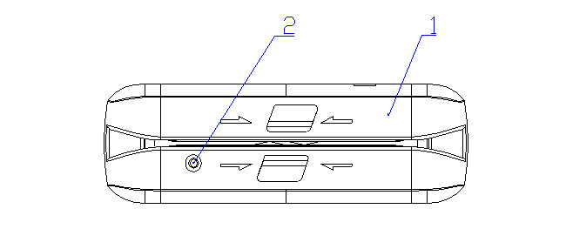

1. Main housing
2. Status LED (blue and red)

DIP Switch Definition
There is a DIP Switch on the main board. The settings definition is following:

SW1 | SW2 | Interface Mode
ON | ON | USB Virtual COM Port
ON | OFF | USB HID Mode
OFF | ON | RS232 Mode (115200,8,N,1)
OFF | OFF | RS232 Mode (9600,8,N,1)

SW4 | Status
ON | F/W updating mode
OFF | Working mode
SW3 has no definition.

Setting Utility Layout:
