EVZ11-611
Bar code reading engine
Product specification

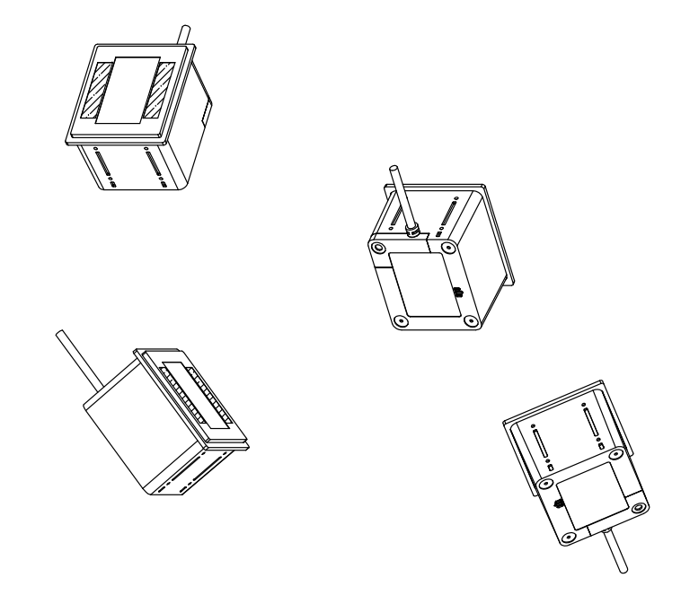

版本号：V1.0

版本描述：

Version | Version description | Date
V1.0 | Original | 2019.05.17

Interface | RS-232（Standard）；  USB（optional）；
Voltage | DC 5V±5%(USB、RS232、RS485)  DC 3.3V±5%（TTL-232）
Current | 135mA（Max） 74ｍA（Min）
Light source | 8pcs of LED
Sensor | CMOS
Sensor resolution | 1280X800pixel（1 million pixels）
Reading angle | Pitch angle:±65°  Skew angle:±60°  Tilt angle:±180°
Field of view | H 54°，V 33°
Min resolution | 〉20%UPC/EAN 13（13mil）
Reference depth of field | Barcodes | Bar code media | density | Size | Min | Max
Reference depth of field | QR Code | Screen | 44.17mil | 23mm*23mm | 4cm | 56cm
Reference depth of field | QR Code | Paper | 44.17mil | 23mm*23mm | 4.5cm | 52cm
Reference depth of field | Code128 | Paper | 20mil | 62mm*15mm | 7cm | 52cm
Reference depth of field | Code128 | Paper | 15mil | 43mm*15mm | 5cm | 45cm
Decode capability | 1D : UPC-A/UPC-E；EAN-8/EAN-13；Code128；Code39；Code93；Code32；  Code11；Codabar；Plessey；MSI；Interleaved 2 of 5；IATA 2 of 5；Matrix 2 of 5；  Straight 2 of 5；Pharmacode；RSS-14；RSS-14 Expanded；RSS-14 Limited；  Composite Code-A；Composite Code-B；Composite Code-C；
Decode capability | 2D：PDF417；Micro PDF417；Data Matrix；QRcode；Micro QR；Aztec；  MaxiCode
Working temperature | -10°C to 60°C
Storage | -10°C to 70°C
humility | 5%~95% (No condensation)
Dimensions | 78mm x 67mm x 54mm(L*W*H)
Secondary development | Supported. Through serial port instructions

Product specification different views 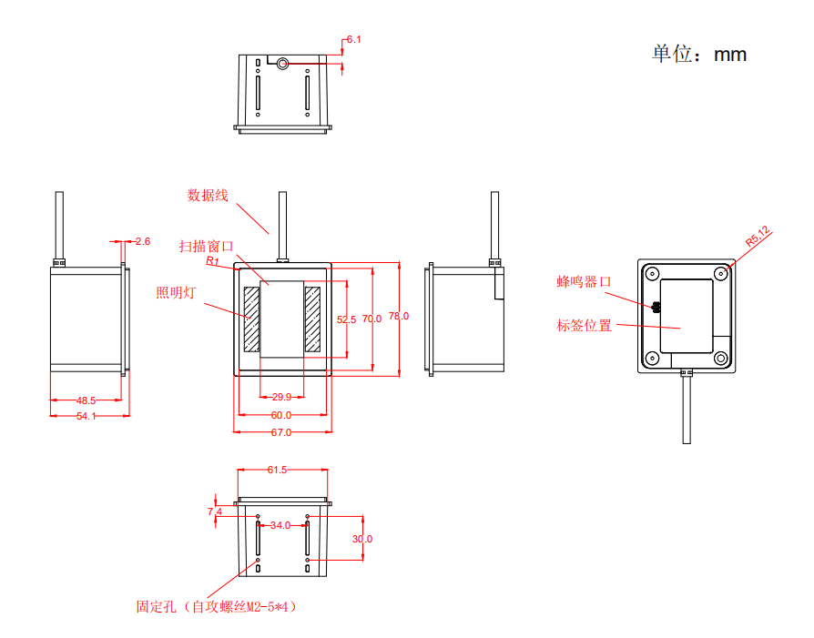

Integration guide

Chapter 1: Installation
Electrostatic protection (ESD)
Z11-611 has been designed to protect against static electricity and uses anti-static packaging. However, anti-static measures should be taken during unpacking and use, such as the use of grounding wrist straps and grounding of work area.
- Dust and dirt
Z11-611 must have sufficient sealing during storage and use to prevent dust, particles or other contaminants from adhering to the lens, circuit board and other components. Dust particles or pollutants can reduce the performance of the engine and even affect the use of the engine.
- surroundings
The normal use of the module is subject to the following environmental requirements.

Working temperature | 0℃ ~ 50℃
Storage | -5℃ ~ 55℃
humility | 5% ~95%（No condensation）

- Heat dissipation considerations
Z11-611 will emit heat during work. Under the condition of continuous operation at full speed for a long time, the heat will accumulate to increase the temperature of the decoder chip. Although the Z11-611 can be adapted to work in high temperature environments, it will increase in high temperature environments.
Image noise reduces image quality and reduces read performance. When considering the application of the Z11-611 in a high temperature environment, it is recommended to test whether the possible read performance degradation is within an acceptable range, and then determine whether to perform proper heat dissipation design.

Designed to reserve space for Z11-611 to form natural convection or forced convection.

Avoid using Z11-611 with insulating materials such as rubber.

- Power on, power off, standby and reboot
Power on: Connect the product to the host, and the scan engine automatically turns on and is working.
Shutdown: Remove the data cable that connects the product into the USB data cable on the host/power adapter plugged into the RS-232 data.
Re: If the product crashes or does not respond, please turn it off and on again to restart.

- maintenance
* The reading window must be kept clean and the supplier's damage caused by improper maintenance is exempt from warranty liability.
* Avoid hard and rough objects from wearing or scratching the reading window
* Use a brush to remove stains from the recognition window
*Please use a soft cloth to clean the window. Such as glasses cleaning cloth and lens cleaning cloth
*Do not spray any liquid to the identification window
*Do not use any cleaner other than clean water

Mounting orientation
There are 4 self-tapping screw mounting holes on each side of the Z11-611. As shown in the figure below, the left and right direction of the Z11-611 image engine is correct, and the captured image also corresponds to the left and right direction. The figure below shows the appearance of the Z11-611 when placed and installed correctly.

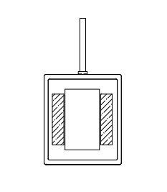

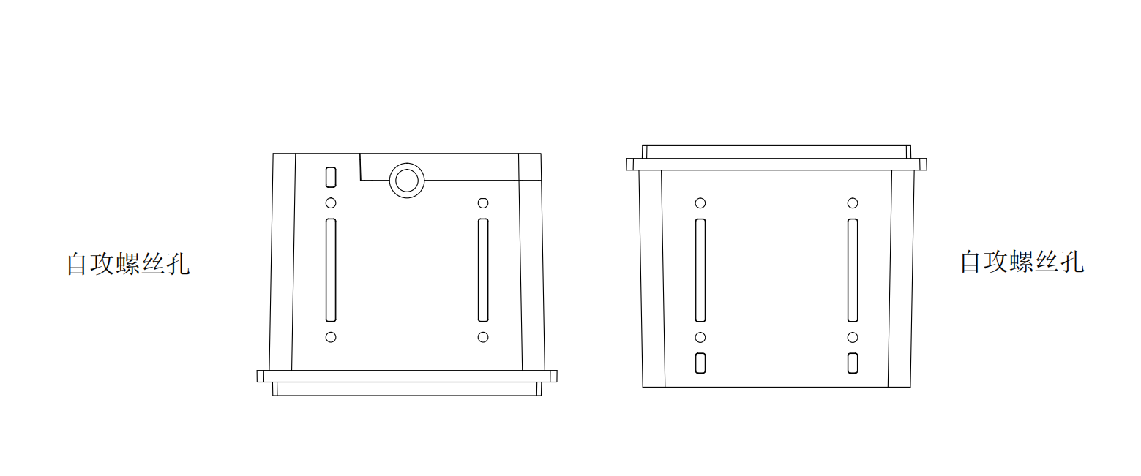
Window size
Mounting
When integrating the Z11-611, refer to the following physical size specifications. Structural design, note that other components cannot be oppressed
Z11-611 device.

Z11-611 Front view（size：mm）
Cable
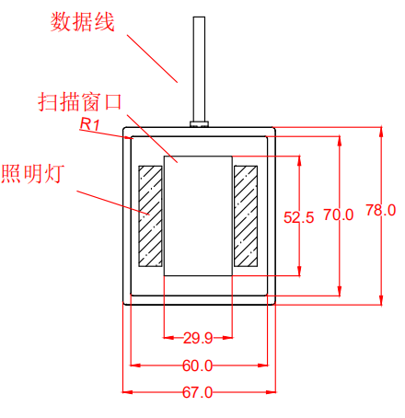
LED
Scan window

Z11-611 side view（size：mm）

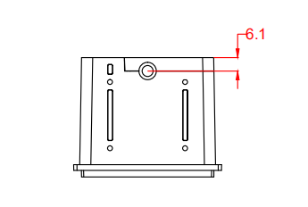

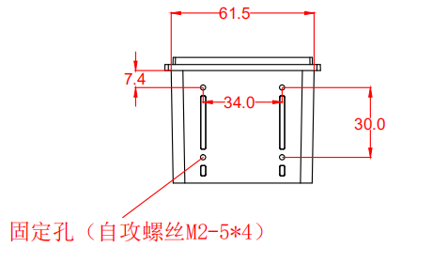
Fixed hole position

Z11-611 Top view（size：mm）

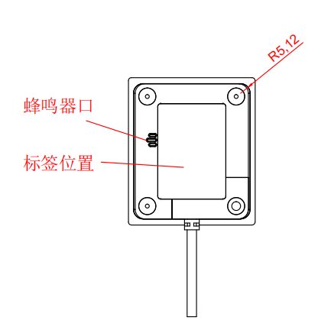
Label position
Buzzer

Scope of View
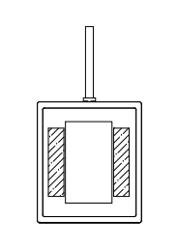
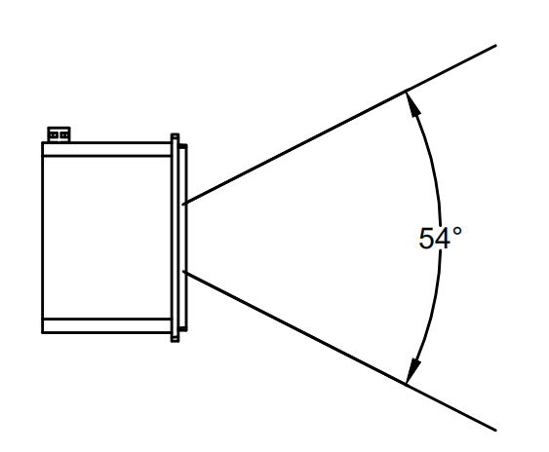

The scan engine has a horizontal angle of view of 54°
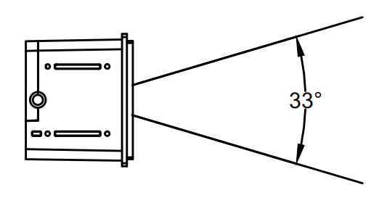

The scan engine has a vertical viewing angle of 33°

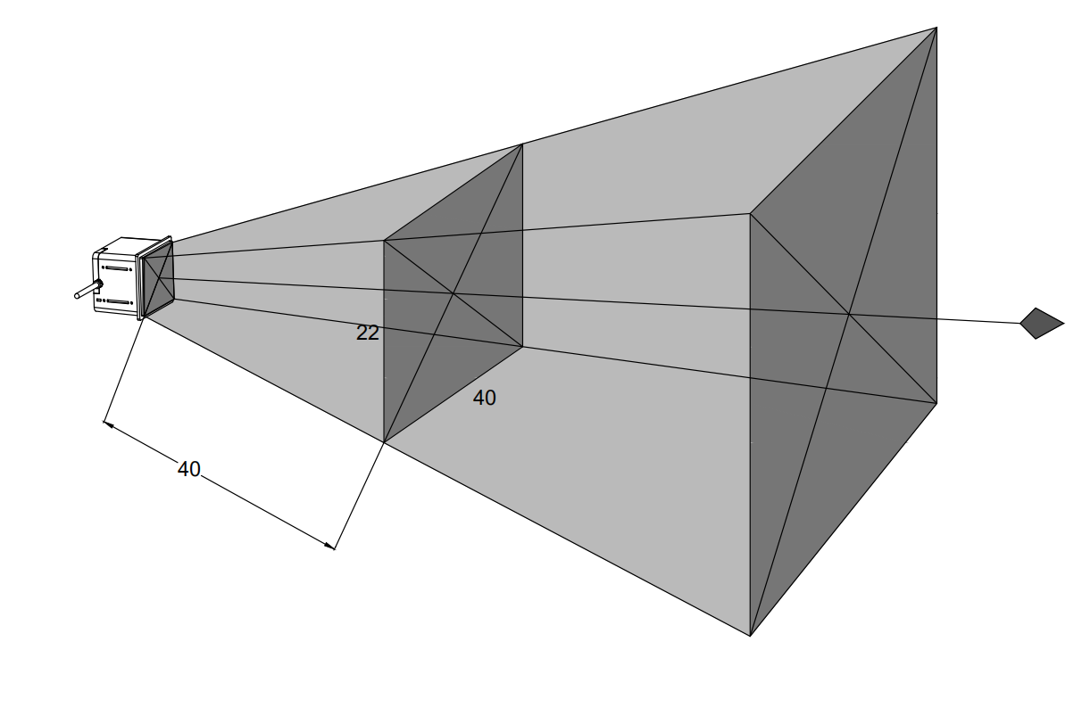
size：CM

Item | Specification
Imaging range (L x W) at a distance of 40 cm from the window | 22cm x40cm

